|  |
| --- |
| The Lunacy of Search Term CTAs in TV Ads | State of Digital |
| As seen on TV: Ofcourse the Advertisements  Discussing how the pandemic affected the advertising trends over the television |
| |  |  |  | | --- | --- | --- | | Chinmay Garg, B16CS041 | 5/29/20 | Sociocultural Theories | |

[Soft Traditional Tabla Music]

*सुबह जलाओ, शाम जलाओ, चारों दिशाओं को महकाओ…*

Well, I don’t know how many people this television advertisement was able to compel to burn their *dhoop* (at least not me, I am allergic to all kinds of *dhoop* and *agarbatti* smoke), but one thing for sure that people are doing every morning and evening these days during lockdown… is watching television, says not me but the statistical report by Broadcast Audience Research Council of India (BARC)-Nielsen. Television viewership has seen a sharp increase of 37% from March 21 to 27 as compared to the pre-lockdown period from January 11 to 31, with the highest rise witnessed in the news viewership – a whopping 298%.

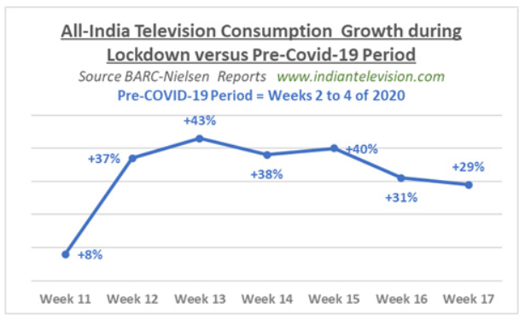

This should be a really great news for our television industry, as more viewership directly translates to more advertisements, but had that been the case, I would not be writing this report. Speaking on television advertising volume trends, Matt O’Grady (Global Commercial President, Nielsen Media), mentions India as an outlier in the global trend. He further points that “In week 1 of the lockdown advertising volumes saw a 13% increase when compared to week commencing 14 March 2020 to 11 January-31 January 2020. Social advertising (+147%), food and beverage (+36%) and banking and finance investment (+47%) drove the advertising volume increases. However, these volume increases did not equate to a similar rise in advertising revenue.”

Peculiar, isn’t it? The viewership increased, the advertising volume increased, but not the revenue for these television channels? Well, if you have been closely monitoring these advertisements, you would have noticed many more such peculiarities. One such example is the very advertisement I opened this essay with. This jingle belongs to an advertisement of ‘*devdarshan dhoop*’, and it first surfaced in 2012, 8 years ago from now. Similarly, ‘amul’ and ‘hajmola’ also are airing ads that date way back. Well, certainly old is gold, but not in advertisements, they need to constantly evolve and keep up with the times, then what is the reason that brands are now using their old ads? If you are thinking that this question will be answered by the end of this journal, then you are going to be disappointed. This journal is written to record the impact that I have observed on television advertisement industry and to mention my thoughts over them, not to research the causal relationships of it.

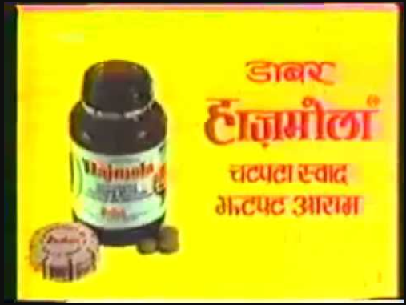 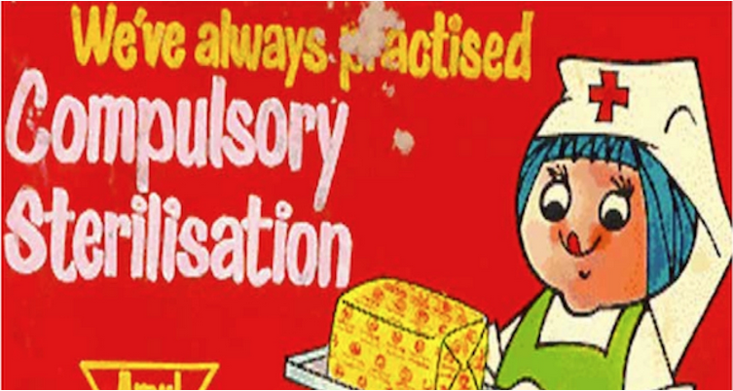

Going back to the topic, one of the reasons might be that the contracts for these advertisements have expired, but they can always renew these contracts, or on account of the immense success of shows like ‘Ramayan’ and ‘Mahabharat’, they might also be trying their hands on targeting for nostalgia… I cannot say anything for sure. In my opinion, these ads are still better than many that are shot hastily with limited resources in the lockdown period. One such example is that of ‘suthol’, where Akshay Kumar, in a white background says, “खुद सुथोल स्वछ बनोगे, तभी तो स्वच्छ बनेगा हिंदुस्तान.”, and then the whole ad is repeated again. If you ask me, its one of the lamest ads that I have ever seen. I don’t understand when a brand can hire Akshay Kumar, why can’t it hire a good creative team? And such lame ads are becoming the norm during lockdown.

Another thing that I noticed was the lack of temperature in the first week of May, but later I found out that it was due to a phenomenon called Western Disturbances, which caused sporadic showers in Northern India, and temporarily brought down the temperature. Guess what else was missing… Ads of AC, cooler, and fans (if you really wish me to list them out, it would also include talcum powders, anti-itching creams, dabar thanda tel, rasna, glucose, etc). These ads were completely absent during April and most of May. Only in the last week of May (when the lockdown rules eased out and electronic shops and markets started opening), I was able to see ads of cooler (Symphony and Summercool) and fans (Usha and Bajaj) coming up (but none of ACs). Quite interestingly, Bajaj was marketing its fan with a tag line of ‘anti-germ + bye-bye dust’. They went on to advertise their fan as ‘*hawa ki dawa*’. On the same lines, a famous washing powder brand is now promoting itself not on the basis of how it whitens and brightens the clothes, but on how washing from it is effective in killing virus from your clothes.



New unheard brands advertised during April and early May, and noiselessly disappeared in the second half of May. This happened maybe because TV channels reduced their advertisement pricing, as there was a lack of big brands willing to advertise giving rise to empty advertisement slots. I observed an absence of ads from automobile companies, home delivery-based companies, accommodation and travel companies. On the other hand, there was a rise in advertisements by healthcare companies (e.g. Leeford Healthcare Ltd., Zee Pharma, Dawa India, Manforce, etc), medical insurance companies (e.g. Policy Bazar, LIC, etc), and FMCG companies which sell products like soap and sanitizers (e.g. Lifebuoy, Dettol, Godrej, etc).

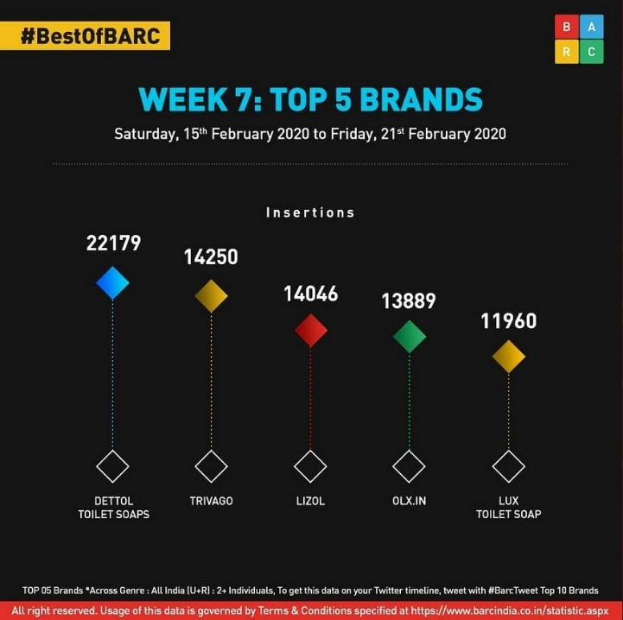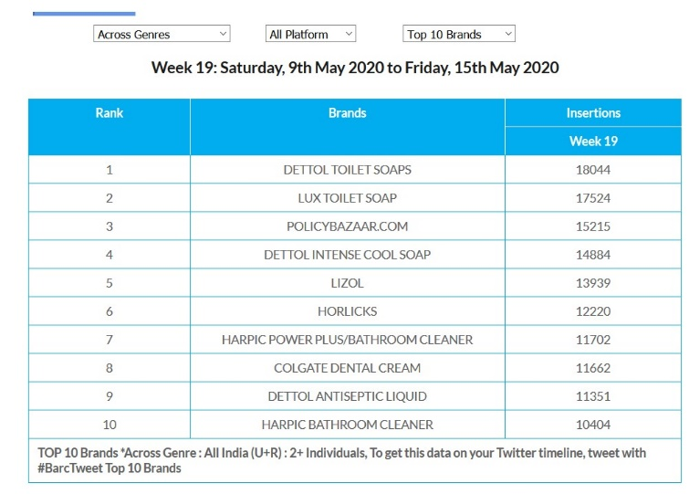

I don’t mean to say that everything is gloomy for the advertising industry. Come on, think about it, a nationwide lockdown means no cinema ads, no highway banners, no metro ads, no airport flyers, many people opting out of newspaper, and all this leaves not many options for an advertiser to go to, and this makes television a very obvious and lucrative choice for them. Especially after the postponement of IPL 2020 and Tokyo Olympics 2020, marketing departments of many big corporations have freed up funds in their hands, which can either be sent back to the financial department to keep the company afloat or can be reinvested in advertising in some other form. Its not like television channels are losing out on ads.

What advertisers are doing now is following the textbook concept of marketing known as STP model, which stands for Segmentation, Targeting, and Positioning. It is the standard boilerplate of everyone looking for a marketing solution. Step 1 is to Segment the user base into different segments based on factors like geography, demography, behavior, and psychography. Once we have a pertinent gamut of such segments, comes step 2, which is to identify the segments which are propriety for us. This is our target audience. The 3rd and most crucial step is the Positioning of our brand/product in the market. So, what these companies are doing right now is playing with the psychography of the customer space. They are convincing the populace on the importance of their product by riding over the wave of covid pandemic, and introducing a behavioral change in the people’s lifestyle. Now, there are brands which do not fit in this marketing niche which seemed to have appeared out of nowhere, like those in automobile and hospitality industry, and thus their absence from the marketing spaces; and then there are those who chose to adapt like the bajaj ‘hawa-ki-dawa’ fans, and are coming up with relatable advertisements, although they may not be that convincing but surely will make an impact on people’s memory. This lockdown (or rather the nature of it) allows us to do a sociological analysis of how advertisements affect our society and how society and circumstances influence advertisements. We will also get to see that if saving money on advertisements is a good strategy in the tough times or not? Also, presenting everything in terms of anti-covid capabilities is companies being opportunistic or adaptive? It would be interesting to ponder over such questions.